PYTHON ACTIVITY BASED LEARNING

TAMMINA SHANMUKHA TANMAI
-CSM3
ROLL.NO:26001034

PROGRAM-1

1. Problem statement
Develop a Python program to evaluate examination answers by comparing students' answer strings with a predefined answer key. The program should calculate correct, incorrect, and unanswered responses, apply negative marking, and display student-wise results.

2. Objectives
- To compare student answers with the correct answer key.
- To count correct, incorrect, and unanswered questions.
- To calculate marks using negative marking.
- To process multiple students using loops.
- To display each student's examination result.
3. Assumptions
- Each student answers five questions.
- The answer key contains five correct options.
- Each correct answer carries 4 marks.
- Each incorrect answer deducts 1 mark.
- An unanswered question receives zero marks.
- Answers are entered as A, B, C, or D; lowercase letters are accepted.
- The program stores results during execution only.
4. Algorithm
- Start.
- Store the correct answers in a tuple.
- Set marks for correct and incorrect answers.
- Input the number of students.
- For each student, input their name and answers.
- Compare each answer with the answer key.
- Count correct, incorrect, and unanswered questions.
- Calculate the final score.
- Store the student's results.
- Display results for all students.
- Stop.
5. Flowchart
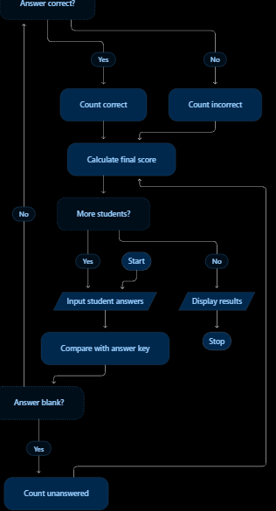

6. Pseudocode
START
STORE answer key
INPUT number of students

FOR each student
INPUT student name
INPUT answers

SET correct = 0
SET incorrect = 0
SET unanswered = 0

FOR each question
IF answer is blank
unanswered = unanswered + 1
ELSE IF answer matches answer key
correct = correct + 1
ELSE
incorrect = incorrect + 1
END IF
END FOR

score = (correct * 4) - (incorrect * 1)
STORE student result
END FOR

DISPLAY all student results
STOP

7.Python source code
answer_key = ("A", "B", "C", "D", "A")

students = {
"Ravi": ["A", "B", "C", "D", "B"],
"Sita": ["A", "B", "C", "A", ""]
}

for name, answers in students.items():
correct = 0
incorrect = 0
unanswered = 0

for i in range(5):
if answers[i] == "":
unanswered += 1
elif answers[i].upper() == answer_key[i]:
correct += 1
else:
incorrect += 1

score = correct * 4 - incorrect

print("\nStudent:", name)
print("Correct Answers:", correct)
print("Incorrect Answers:", incorrect)
print("Unanswered:", unanswered)
print("Total Score:", score, "/ 20")
8. Test cases
Test case | Correct | Incorrect | Unanswered | Expected score
All answers correct | 5 | 0 | 0 | 20
One incorrect | 4 | 1 | 0 | 15
One unanswered | 4 | 0 | 1 | 16
Two incorrect, one unanswered | 2 | 2 | 1 | 6
All unanswered | 0 | 0 | 5 | 0

9.output
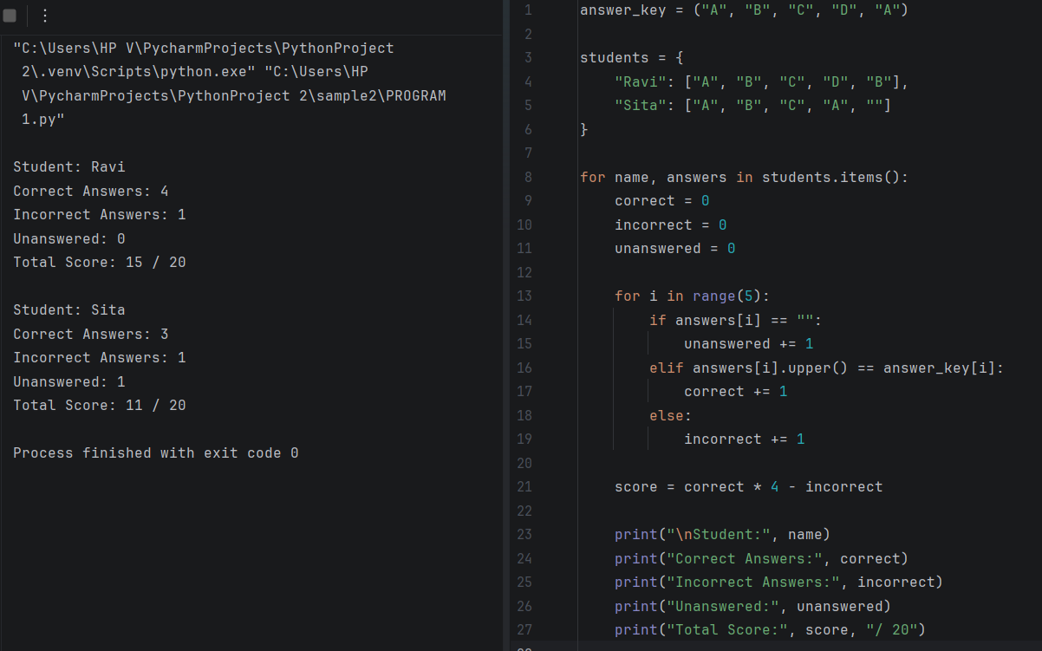

10. Conclusion
The Python program successfully evaluates examination answers by comparing them with an answer key. It calculates correct, incorrect, and unanswered responses, applies negative marking, and produces student-wise results. It demonstrates the practical use of fundamental Python programming concepts.

